It is the responsibility of staff to ensure that they have read applicable pupil behaviour risk assessments and are clear on strategies to be used.
De-escalating
Recognised de-escalation strategies include:
- acknowledging the pupil’s anger/distress
- having the minimum number of staff present necessary
- one adult leading
- using a calm tone of voice and clear, direct language or pupil's preferred method of communication (focusing on the behaviours you want them to display rather than the ones you don’t)
- adopting a non-threatening body stance and body language
- allowing adequate personal space
- using non-verbal cues
- distracting the pupil from the source of their anger or distress by discussing another topic of their interest
- providing options (within limits) to help the pupil feel they are still in control of their decisions.
Incident Response:
Where possible, staff members should:
- have one adult leading engagement with the pupil
- if necessary, seek help from other staff members to ensure the safety of the pupil and others
- ensure there are minimal adults visibly present
- give the pupil space
- suggest the use of quiet spaces – only at timely intervals – not repeatedly
- limit language used – attempting to distract or discuss at this point can escalate the situation
- move all other pupils in the vicinity to a safe distance away from the pupil behaving dangerously
- remove objects that may be used to cause harm from the vicinity of the pupil, if safe do so
- avoid confrontation with the pupil
- this is not the time to discuss the events that have led up to this within the pupil’s hearing as this will contribute to anxieties

Response and Recovery 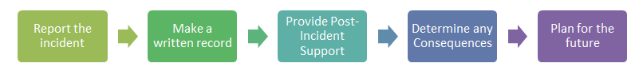
Incident follow up
- give the pupil time and space to relax
- at a later point enable the pupil to share what happened and their emotions in a way that works for them – drawing, writing, discussion, etc
- listen – provide no judgment
- use restorative approaches
- use a solution focused approach
- think about similar scenarios and review responses and possible earlier interventions with the child and other stff

Date reviewed: August 2022

